# Analysis and Design Unit – Evidence

## A.D. 1 – Use Case Diagram *W5

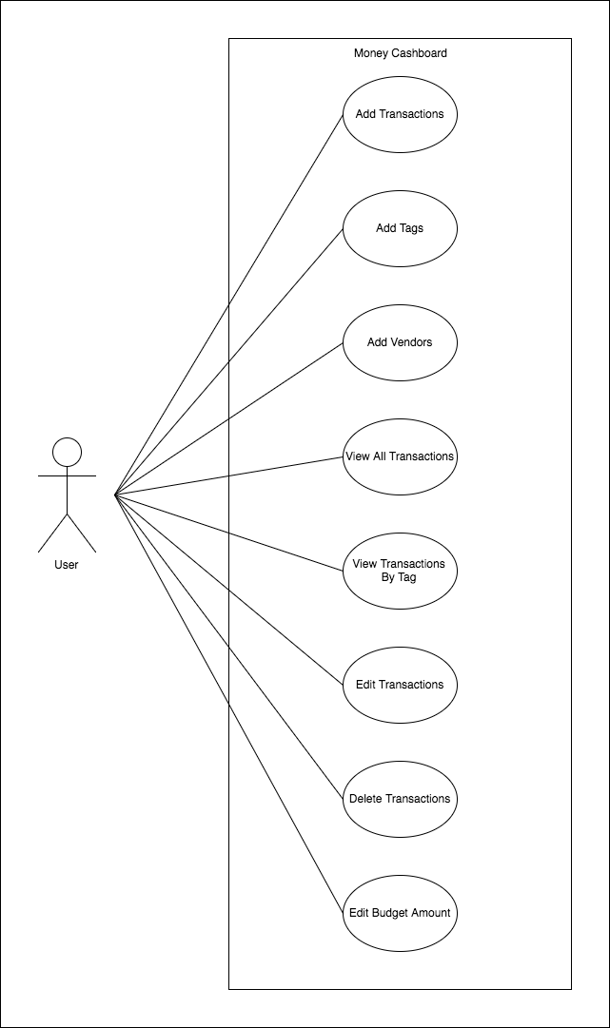

## A.D. 2 – Class Diagram *W5

## A.D. 3 – Object Diagram *W5

## A.D. 4 – Activity Diagram *W5

## A.D. 5 – Inheritance Diagram *W9

## A.D. 6 Implementation Constraint Plan *W5